Werner Lab Maintenance Procedures for 18°C Reserve Stocks

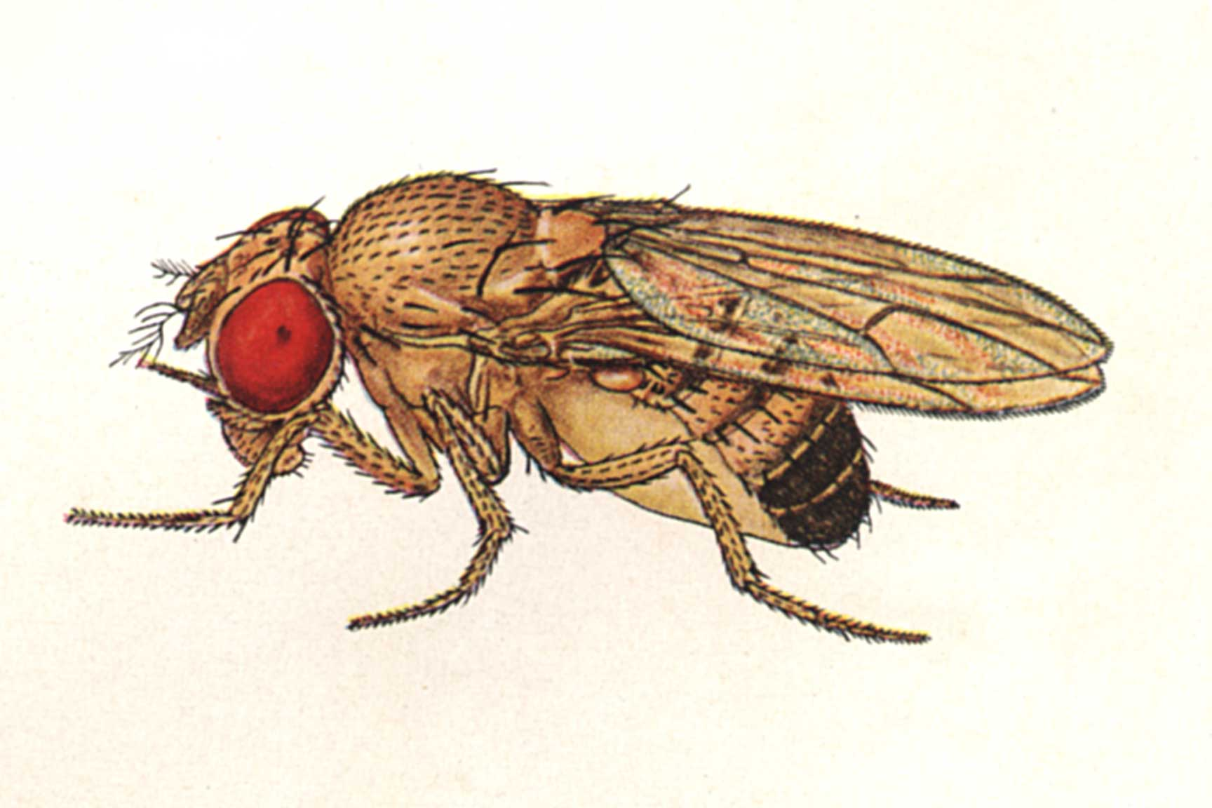

Assembled By Zachary Johnson - 2013

Prepping/Selecting Food Vials
Standard glass food vials, holding ≈ 12 ml of sugar food, are used for maintaining the 18°C stocks. Fresh food vials should be removed from the fridge 15 minutes before bumping to allow them to approach room temperature. Do not use vials that are more than 1 week old. Do not select food vials that are under-filled because they will cause an early degradation of the environment within the vial due to the lack of sufficient food for the flies and larvae.
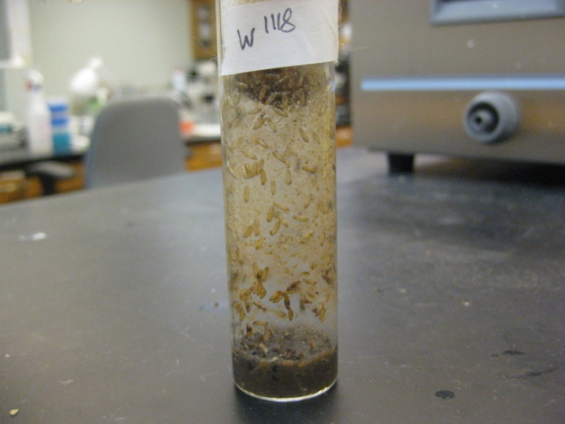
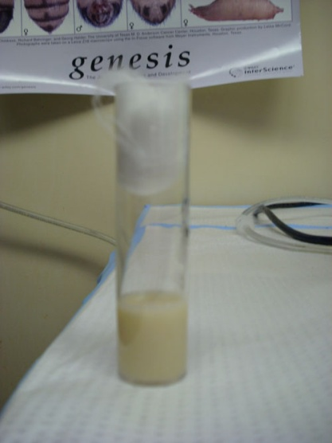
A dirty, under-filled vial
A vial of desirable food volume

Determining when to Bump - Evaluating the Fly Stocks
Although freshly-bumped, healthy stocks may go unattended for as long as 14 days, all stocks should be evaluated every 7-10 days. Evaluate the vials based on two criteria: cleanliness and fly age. Bump only freshly-hatched flies from the second-oldest vial of each stock to new food. Look for empty pupa cases against the light to determine if the flies in question are still the old parents (no empty pupa cases visible) or the new generation (a good amount of of empty pupa cases visible, while some are still black and yellow). Evaluate each stock’s set of vials to determine which stocks should be bumped to new food. Stocks that are not ready to be bumped will be ready next time.

Cleanliness
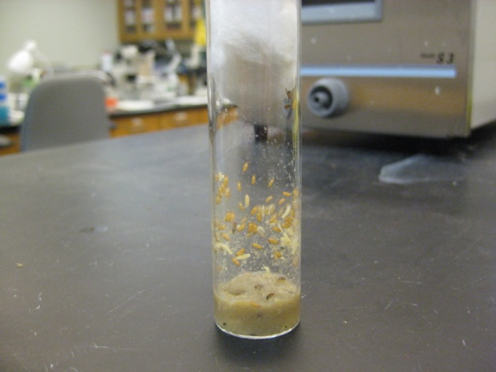
Stocks should be kept in clean vials, although all vials will brown and darken through their lifespan. Excessively “grimy” or graying vials should be bumped as soon as the new generation has hatched because these conditions are indicative of excessive bacteria in the vial. Some cases may require extra bumping after 2-4 days, until the conditions improve.

Fly Age
Ideally, the majority of flies bumped onto new food should be newly hatched from their pupae. Evaluating the pupae is a good way to find out if the flies are the old parents that you don’t want to bump or the new generation that you do want to bump. Vials with abundant pupae are desirable. If approximately half of the pupae are dark, while others are empty, then most of the present flies will be of the new generation that you shall bump onto new food.
A young, clean vial.

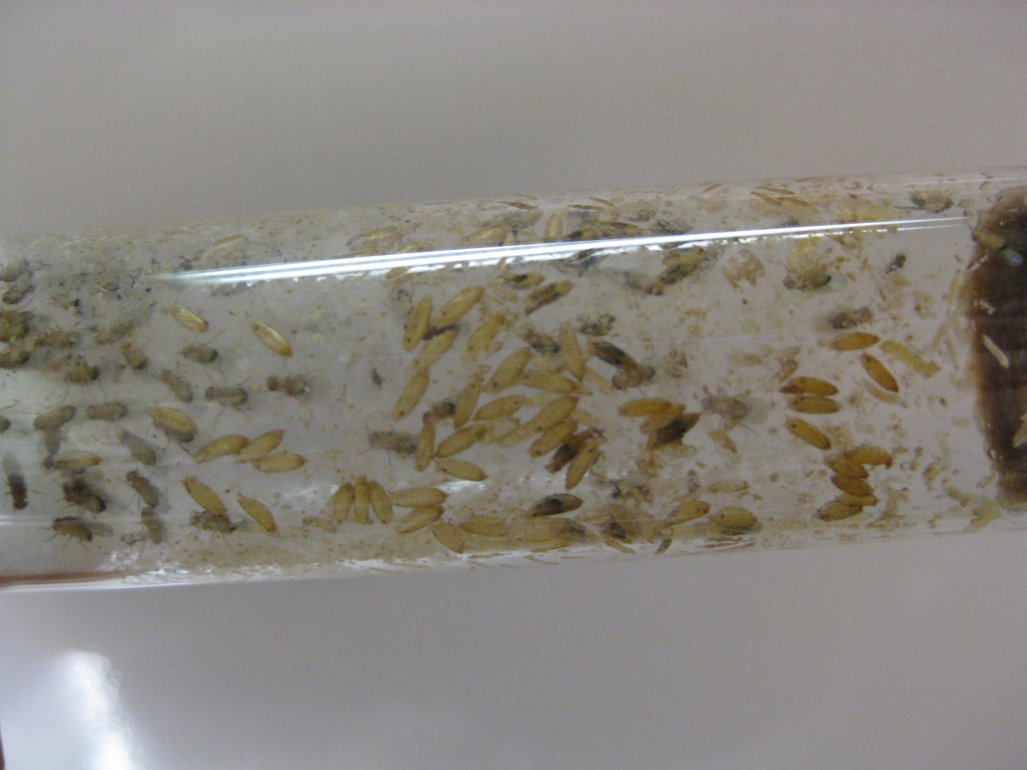
A vial having mostly empty pupa casings, and thus, young flies.

Bumping
The goal of retaining 18°C stocks is to maintain a reserve population of each strain. This can be accomplished most efficiently with a smaller population of flies than is kept in regular vial stocks. Bumping too many flies will result in an earlier decline in vial conditions and the need for extra bumping. Bumping too few flies puts stocks at risk of extinction. In most cases, bumping 15 flies to a new vial is sufficient to maintain healthy vials without a risk of stock extinction. This figure may have to be adjusted for stocks with particularly high or low fecundity. Two vials of different ages are generally retained for each stock, but a third may be kept if there is ever doubt surrounding whether sufficient flies exist in the two youngest vials. To protect against the threat of mites, no one vial should be kept for longer than four weeks.

Stock Extinction
Sometimes stocks might go extinct. When this happens, it must be reported to Dr. Werner immediately. Most stocks can be repopulated by taking a founder population of 15-20 flies from the redundant, room temperature stock that is kept in Dow 217. If stocks went entirely extinct, the fly stock list on the 5th and 2nd floor lab computers must be changed to reflect the reality.

